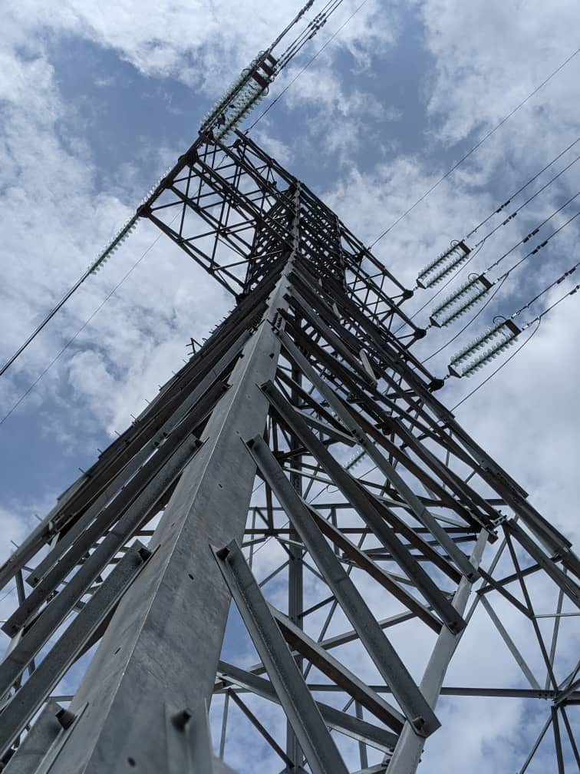




COMMITTEE REPORT ON THE REVIEW OF EXISTING OPERATIONS AND RESTORATION MANUALS

GHANA GRID COMPANY LTD
COMMITTEE REPORT ON THE REVIEW OF EXISTING OPERATIONS AND RESTORATION MANUALS
- Introduction
Technical Directives, including Operating Procedures, are critical for the effective coordination of operations on every power system. They are required to provide detailed information to operations and maintenance personnel on the procedures required to be followed in the process of carrying out operations on equipment and installations on the power system.
These include General Principles underpinning system operations, which each operating and maintenance personnel must know and understand in carrying out his/her work. It also includes Operating Procedures to be followed at substations when taking equipment in/out of service as well as Dispatch Procedures such as System Restoration Procedures, used to restore power system equipment and systems to service after being taken out for maintenance or following a system disturbance.
The existing Technical Directives, which pre-date the formation of GRIDCo have not been reviewed since the early 1990’s. Accordingly, these documents have become outdated due to the extensive expansion of the network.
- Review Committee
Consequently, the Chief Executive (CE) constituted a Standing Committee on June 11, 2021 (copy of email notification is attached as Appendix A) to review all existing operations and restoration manuals to reflect current operating conditions on the network. The committee is composed as follows:
- Frank Otchere (Chairman) – SOD
- Aaron Adjabeng (Secretary) – TSD
- Frederick Okang – EP&D
- Joseph Enin – NNS
- Frederick Akomeah – SOD
- Aaron Tetteh – SNS

However, due to the enormity of the assigned task and the level of expertise required to carry out a comprehensive work, the following were co-opted to assist the team achieve its objectives:

- Anthony Ansah – SOD
- Nana Adwoba Manyekyi Afrifa – SOD

- Mandate of the Committee

The mandate of the Committee was asserted as follows:
- to review the existing Operations and Restoration manual and submit a report to the CE by June 30, 2021.
- to meet periodically to review the manual to ensure it reflects current operating conditions.

- Action Plan
The Committee held its maiden meeting in the Blue Conference room at SCC on June 16, 2021, to develop an action plan for executing the assignment.
At the maiden meeting, the Committee observed that because the existing procedures had not been updated since the early 1990’s, a lot of work was required to be done to update and transform them to reflect current operating conditions.
Upon assessment of the work at hand, the committee asserted that more time was required for the assigned work to be duly completed and requested for an extension of the deadline. The committee also requested that weeklong monthly meetings be held offsite to enable it to insulate itself from the pressures of daily work to focus fully on the assigned task.
Both requests were granted by the Chief Executive. The committee therefore settled on Royal Nick Hotel in Tema, as the offsite meeting place. After extensive deliberations and considerations of other commitments of members of the committee, the committee agreed on the following action plan:
MEETINGS | PLAN
1st | Develop Operating Procedures for nine (9) selected substations
1st | Update NITS Equipment Outage Management Procedure
2nd | Develop Operating Procedures for ten (10) selected substations
2nd | Develop a Manual for Power System Dispatch in Normal State
3rd | Develop Operating Procedures for ten (10) selected substations
3rd | Develop a Manual for Power System Dispatch in Alert State
4th | Develop Operating Procedures for ten (10) selected substations
4th | Develop a Manual for Power System Dispatch in Emergency State
5th | Develop Operating Procedures for ten (10) selected substations
6th | Develop Operating Procedures for ten (10) selected substations
6th | Develop Power System Restoration Procedures
7th | Develop Operating Procedures for remaining seven (7) substations
7th | Develop Power System Equipment Commissioning Procedure
  - Methodology
The following methodology was adopted by the Committee:

- Collation of existing Operating Diagrams for all substations in the NITS.
- Vetting and validation of the existing substation Operating Diagrams and nomenclatures with the support of the respective Operating Supervisors in the Areas to ensure that the diagrams reflect the current equipment topologies (arrangement) at the various substations.
- Review of existing operating procedures using the Validated Operating Diagrams.
- Development of new procedures for recently commissioned substations.
- Development of procedures for power system Dispatch Operations.

  - General Observations

Some observations were made by the team during the execution of the assigned task. Below are these observations and the remedies adopted to address them.

No. | Observation | Remedies
1 | There were significant topological differences between the existing substation operating diagrams and the SCC SCADA NMS diagrams for some substations. | In conjunction with Operating Supervisors of respective Operational Areas, the team ensured that all operating diagrams were updated to correspond with the current topology of substation.
2 | There are a few instances where Nomenclatures in the Operating Diagrams were different from nomenclatures embossed on equipment in the switchyard. Additionally, some naming convention errors were identified in some nomenclatures. | All identified nomenclature errors were corrected by the team. The team shall communicate all identified cases of mismatched nomenclatures to respective Operational Areas for the necessary correction to be effected.
3 | The need for the Committee to visit some substations (especially the remote ones within Operational Areas) to verify and validate Operating Diagrams. | All Operating Diagrams will be revalidated during a visit by the team to the Areas as part of implementation of these procedures.
4 | Modifications made to some substations that supply power to NEDCo such as the installation of an outdoor circuit breaker and associated disconnect switches were not captured in the operating diagrams of these substations. | Operating diagrams were updated to reflect the current equipment topology in these substations.
5 | Operating diagrams of Techiman (TH26), Sunyani (SN27), Tamale (TM28) and Bolgatanga Substations (BG29) contain power equipment which are operated by NEDCo. This is unacceptable | Drawings were simplified by removing equipment which are operated and maintained by NEDCo.
  - Completed Works
The Committee per the assigned mandate completed the review of Operating Procedures for all the sixty-one (61) substations within the NITS. In addition, a new procedure was developed for the Elubo Substation which has been in existence since the year 2000 but lacks procedures for its operation. Also, new procedures were developed for newly constructed Pokuase and Kasoa Substations, Kpone Collector, Dawa and Free Zones Substations, and Bridge Power, AKSA, Karpower, Amandi, Cenpower, Tema Thermal (ST50) Power Plants.
The details of the Operating Procedures and their respective numbers are as follows:
PROCEDURE NUMBER | TITLE
TD-OP-001 | Operating Procedure for Akosombo (A1) Substation
TD-OP-002 | Operating Procedure for Volta (V2) Substation
TD-OP-003 | Operating Procedure for Smelter (S3) Substation
TD-OP-004 | Operating Procedure for New Tema (E4) Substation
TD-OP-005 | Operating Procedure for Achimota (H5) Substation
TD-OP-006 | Operating Procedure for Winneba (W6) Substation
TD-OP-007 | Operating Procedure for Cape Coast (C7) Substation
TD-OP-008 | Operating Procedure for Takoradi (T8) Substation
TD-OP-009 | Operating Procedure for Tarkwa (R9) Substation
TD-OP-010 | Operating Procedure for Prestea (P10) Substation
TD-OP-011 | Operating Procedure for Dunkwa (D11) Substation
TD-OP-012 | Operating Procedure for Obuasi (B12) Substation
TD-OP-013 | Operating Procedure for Kumasi (K13) Substation
TD-OP-014 | Operating Procedure for Nkawkaw (N14) Substation
TD-OP-015 | Operating Procedure for Tafo (T15) Substation
TD-OP-016 | Operating Procedure for Akwatia (Q16) Substation
TD-OP-017 | Operating Procedure for Old Kpong (G17) Substation
TD-OP-018 | Operating Procedure for Konongo (K18) Substation
TD-OP-019 | Operating Procedure for Kpong GS (Z19) Substation
TD-OP-020 | Operating Procedure for Asawinso (AS20) Substation
TD-OP-021 | Operating Procedure for New Obuasi (NB21) Substation
TD-OP-022 | Operating Procedure for Asiekpe (AP22) Substation
TD-OP-023 | Operating Procedure for Ho (HO23) Substation
TD-OP-024 | Operating Procedure for Kpeve (PE24) Substation
TD-OP-025 | Operating Procedure for Kpando (PU25) Substation
TD-OP-026 | Operating Procedure for Techiman (TH26) Substation
TD-OP-027 | Operating Procedure for Sunyani (SN27) Substation
TD-OP-028 | Operating Procedure for Tamale (TM28) Substation
TD-OP-029 | Operating Procedure for Bolgatanga (BG29) Substation
TD-OP-030 | Operating Procedure for Bogoso (BS30) Substation
TD-OP-032 | Operating Procedure for Takoradi Thermal (TT32) Substation
TD-OP-033 | Operating Procedure for Sogakope (SK33) Substation
TD-OP-034 | Operating Procedure for Esiama (EA34) Substation
TD-OP-035 | Operating Procedure for Yendi (YD35) Substation
TD-OP-036 | Operating Procedure for Elubo (EL36) Substation
TD-OP-037 | Operating Procedure for Mallam (M37) Substation
TD-OP-038 | Operating Procedure for Sawla (SA38) Substation
TD-OP-039 | Operating Procedure for Aflao (AF39) Substation
TD-OP-041 | Operating Procedure for New Tarkwa (NR41) Substation
TD-OP-042 | Operating Procedure for Akyempim (AY42) Substation
TD-OP-043 | Operating Procedure for Kenyasi (KY43) Substation
TP-OP-050 | Operating Procedure for Tema T. (ST50) Substation
TD-OP-053 | Operating Procedure for Zebilla (ZB53) Substation
TD-OP-055 | Operating Procedure for Buipe (BP55) Substation
TD-OP-056 | Operating Procedure for Kintampo (KP56) Substation
TD-OP-057 | Operating Procedure for Ayanfuri (AR57) Substation
TD-OP-058 | Operating Procedure for Anwomaso (AW58) Substation
TD-OP-059 | Operating Procedure for Accra East (AE59) Substation
TD-OP-060 | Operating Procedure for Smelter II (SM60) Substation
TD-OP-061 | Operating Procedure for New Abirem (NA61) Substation
TD-OP-062 | Operating Procedure for Mim (MM62) Substation
TD-OP-063 | Operating Procedure for Brerekum (BR63) Substation
TD-OP-064 | Operating Procedure for Juabeso (JB60) Substation
TD-OP-066 | Operating Procedure for Takoradi Extension (TE66) Substation
TD-OP-068 | Operating Procedure for Winneba (WA68) Substation
TD-OP-069 | Operating Procedure for Tumu (TU69) Substation
TD-OP-070 | Operating Procedure for Kadjebi (KD70) Substation
TD-OP-071 | Operating Procedure for Afienya (AA71) Substation
TD-OP-072 | Operating Procedure for Free Zone (Fz72) Substation
TD-OP-073 | Operating Procedure for Bawku (BK73) Substation
TD-OP-075 | Operating Procedure for Kpone Collector (KC75) Substation
TD-OP-076 | Operating Procedure for Cenpower (CP76) T. P. Substation
TD-OP-077 | Operating Procedure for Karpower (KA77) Power B. Substation
TD-OP-078 | Operating Procedure for Obotan (BT78) Substation
TD-OP-079 | Operating Procedure for Aksa (AK79) Thermal Plant Substation
TD-OP-080 | Operating Procedure for Dawa (DA80) Substation
TD-OP-081 | Operating Procedure for Adubiyili (AD81) Substation
TD-OP-082 | Operating Procedure for Nayagnia (NY82) Substation
TD-OP-083 | Operating Procedure for Accra Central (AC83) Substation
TD-OP-084 | Operating Procedure for Amandi (AM84) Thermal P. Substation
TD-OP-085 | Operating Procedure for Bridge Power (BD85) Substation
TD-OP-086 | Operating Procedure for Pokuase (PK86) Substation
TD-OP-087 | Operating Procedure for Kasoa (KS87) Substation

Please find copies of the above Operating Procedures on the accompanying USD Flash Drive.
In addition to the above procedures, the Committee also updated and developed the following power system operating procedures:
PROCEDURE NUMBER | TITLE
TD-OP-S03 | NITS Equipment Outage Procedure
 | Dispatch Scheduling Procedure (Dispatch Procedures)
 | Procedure for Power System Dispatch (Dispatch Procedures)
 | Power System Restoration Procedure
 | Power System Equipment Commissioning Procedure

- Conclusion
In conclusion, the standing committee achieved its mandate of developing comprehensive procedures for the operation of major equipment within the NITS and other relevant procedures for the power system. In all, Operating Procedures for sixty – one (61) substation were reviewed and updated where necessary. The Operating Procedures for twelve (12) other substations were also developed, bringing the total number of Operating Procedures to seven-three (73). In addition, the Committee developed procedures for Power System Dispatch, Power System Restoration and Power System Equipment Commissioning.
Notable among the observations made by the Committee in the course of its work, are the topological differences between the existing substation operating diagrams and the SCC SCADA NMS diagrams for the same substation and the difference between equipment nomenclatures in the Operating Diagrams and nomenclatures embossed on equipment. Necessary steps were taken by the Committee to address these issues as stated in the report. The committee shall as part of the implementation of these procedures ensure that all identified cases of nomenclature mismatch are corrected in the substations to avert any case of mis-operation.
- Recommendations
In view of the observations that were made during the exercise, the Committee makes the following recommendations:
- All procedures should be signed off by the Director, Technical Services before issue to the relevant Departments.
- All submitted procedures should be reviewed biennially to ensure that they are up to date and always fit for purpose. During these reviews, comments from users will be considered and incorporated in the documents if found to be relevant and appropriate.
- The committee suggests that all the updated procedures should be compiled into an e-book that can be hosted on one of GRIDCo’s e-platforms (ERP, GridApps) to allow easy access by all staff.
- Where operating nomenclatures in the field differ significantly from what is on the Operating Diagrams, it is recommended for the removal of the existing labels and the re-embossment with the correct nomenclatures.
- Periodic visits to Operational Areas by the Committee to engage operations and maintenance personnel to build capacity for the effective use of the Technical Procedures and thereby also obtain feedback to guide future updates of same.
Accordingly, the Committee recommends that henceforth, the Technical Services Department makes provision in its annual budget for these visits and activities of the Review Committee.
- Operating Procedures for new substations and other new power system installations/facilities must be developed and circulated before they are commissioned into operation.

